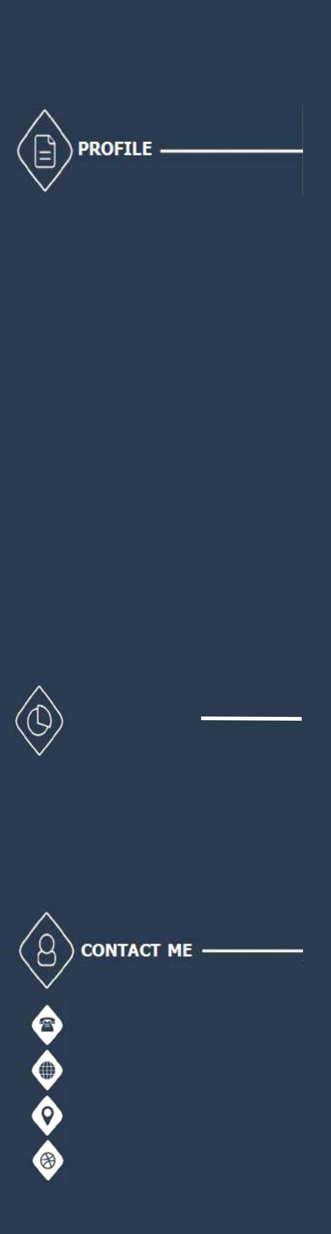

**Soubhagya Ranjan Pradhan**

# QA Test Engineer

* Currently working as Test Engineer with team size around 15 to 20 members having total experience more than 2 years.
* Good understanding of software development life cycle
* Experienced in working with clients, business managers and technical teams for executing concurrent project.
* Proficiency in write test cases as per functionality of product and execute test cases in logical manner.
* Expert of filing bugs in ZOHO with proper bug details.

# OBJECTIVE

A technological mindset aided with experience and the ability to participate

in different areas of product testing. a hustler, an executor who is able to sift through the chaos and take decisions. Always ready to take up new areas of development

### 

### +916370645451

**+917873449864**

Soubhagyapradhan6  
 @gmail.com

**Bangalore, Bhilai**

**India**

**Globussoft Technologies /**Software Engineer In Test

11th December 2019 - PRESENT, Bangalore/Bhilai

* Worked in **2**+ live projects.
* Worked on Online Project Management,  
  E-commerce projects & Social Media Marketing and Employee monitoring projects.

**Qspider /**Software Engineer In Trainee

July 2019-December 2018, Bhubaneswar/Bangalore

* Automated projects based on clock Management.
* Wrote Test Scenarios/Cases.
* Designed & Executed Test Scripts.



**KEY SKILLS – TECHNOLOGY**

* Java, SQL
* Test Case Management
* ZOHO
* PostMan



**CORE COMPETENCIES**

* 2 year’s of experience in the area of Software Testing(Manual

and Automation Testing) with a solid understanding of Analysing Test Requirements, Tracking changes, Test planning

and maintenance of Test Requirements.

* Good knowledge on Web, Desktop, Client Server, Android and IOS Applications
* Well acquainted with all phases of SDLC and STLC .
* Having very good knowledge in Bug life cycle
* Experience in various types of testing:- Functional, Non-Functional, Regression, Re-Testing etc.
* Performed API testing with Postman.
* Well acquainted with Test Automation using Selenium tools.
* Strong in JAVA programming(OOP’s, String, Collection concepts etc).
* Knowledge in SQL querying like Joins, sub queries etc.
* Well acquainted with Project Management Tools like ZOHO.

# STRENGTHS

* Positive Outlook
* Open to Challenging Environment
* Hard and Smart Problem solving skills
* Good Lerner by Observation
* Team work

**HIGHEST EDUCATION**

# B.Tech in Electronics and Communication Engineering from Institute of technical education and research (under Siksha ‘O’Anusandhan University) in the year of 2018 with 6.93 CGPA.

**Types of Projects Handled :**

• Experience in Website Testing, Mobile application testing including Android and IOS.

• Experience in Windows and Mac based desktop applications Testing.

**PROJECTS UNDERTAKEN**

|  |  |
| --- | --- |
| **Project #1** | **EMP Monitor** |
| **Client** | Internal Project |
| **Duration** | Sep-2019 to till date |
| **Development Environment** | Dot Net, C++, PHP |
| **Project Description** | * Manage all the computers in your organization remotely from a centralized location. Emp Monitor account is accessible from any internet-enabled device giving you access from anywhere at any time. With our real-time computer monitoring software, you can view activities as they happen and manage instantly. |
| **Team Size** | 15 |
| **Website URL** | <https://empmonitor.com/> |
| **Responsibilities:** | * Involved in writing and executing test cases based on requirements. * Involved in Smoke Testing, Functional Testing, Re-Testing and Regression Testing, API Testing. Compatibility Testing * Involved in maintenance of Test script. * Defect tracking in ZOHO. * Involved in Testing of its whitelable applications as per the requirement |

|  |  |
| --- | --- |
| **Project #2** | **Socinator** |
| **Client** | Internal Project |
| **Duration** | May -2019 to till date |
| **Development Environment** | Dot Net. |
| **Project Description** | * Socinator is a window-based desktop Application which is all in one multipurpose tool for total Social media automation like Instagram , Facebook , YouTube , Twitter, Pinterest , LinkedIN , Quora , Reddit , Tumblr. It helps to automate daily activities of all social site under a single window. |
| **Team Size** | 12 |
| **Website URL** | [https://www.socinator.com](https://www.socinator.com/) |
| **Responsibilities:** | * Involved in writing and executing test cases with all possible scenarios * Involved in Client side testing. * Involved in Functional Testing, Re-Testing and Regression Testing. * Bug Tracking and Error Reporting. * Involved in Testing of its whitelable applications as per the requirement |

                                                                                     

**DECLARATION**

I do hereby declare that the above given statements are true and correct to the best of my knowledge.

**Soubhagya Ranjan Pradhan**